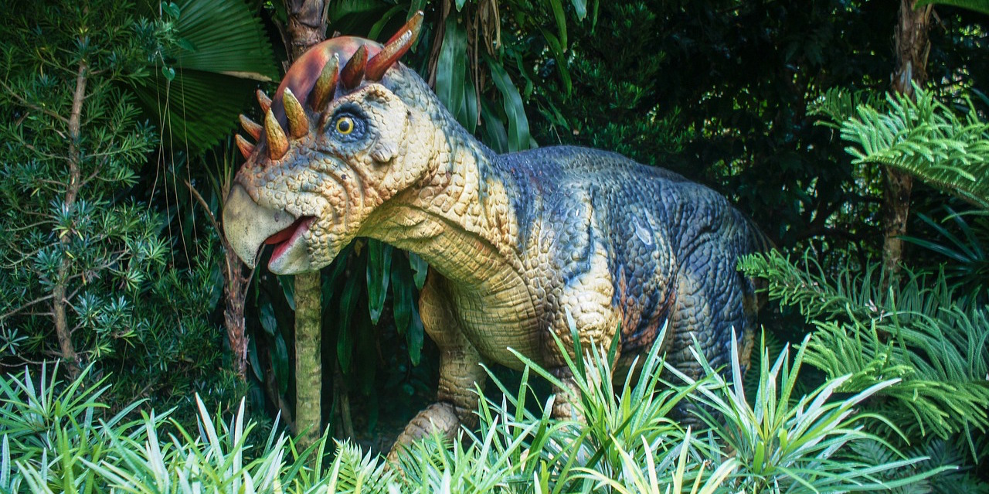

disease at the same rates that we do today, so let’s eat what they ate. And the paleo diet was born. Now diet makers have turned to a new source of inspiration—the dinosaur.

Dinosaurs were able to dominate the planet for thousands of years, but will eating like one make you live a longer and healthier life?

The Jurassic Diet makes a lot of bold claims, so we’re going to separate fact

Diets draw inspiration from all kinds of sources. These sources range from the logical—such as particularly healthy foods that can form the foundation of a diet plan—to the more unusual. In this latter category are inspirations such as geographic locations and periods in history. If a time or place is closely associated with health, physical fitness, and longevity, it won’t be long before someone extrapolates that into a one-size fits all diet plan. Cavemen didn’t suffer from obesity and heart

By Selma Ibanez

FACT and Fiction

The *JURASSIC* Diet:

Eating healthy, living well 16

Vol. 12 No. 1

* We answer your letters!
* Keeping those New Year’s fitness resolutions
* Latest winter health trends
* We look into the latest fad diet and let you know if it makes you as healthy as it promises.

***ALSO inside:***

***Fact and Fiction***

***The Jurassic Diet:***

Living Well

**Eating Healthy,**

Dec 2017